1.13 Interleave Controller



This section will guide you to understand:

* How to perform interleave controllers

**Development Environment:**

* Apache JMeter 5.1.1 Version
* JDK Runtime Environment 11.0.2

This guide has four subsections, namely:

1.13.1 Recording the scripts

1.13.2 Adding interleave controller

1.13.3 Running the scripts in interleave controller

1.13.4 Pushing the code to your GitHub repositories

**Step 1.13.1:** Recording the Scripts

* Open JMeter.
* Right click on Test Plan.
* Click on Thread (Users) -> Thread Group.

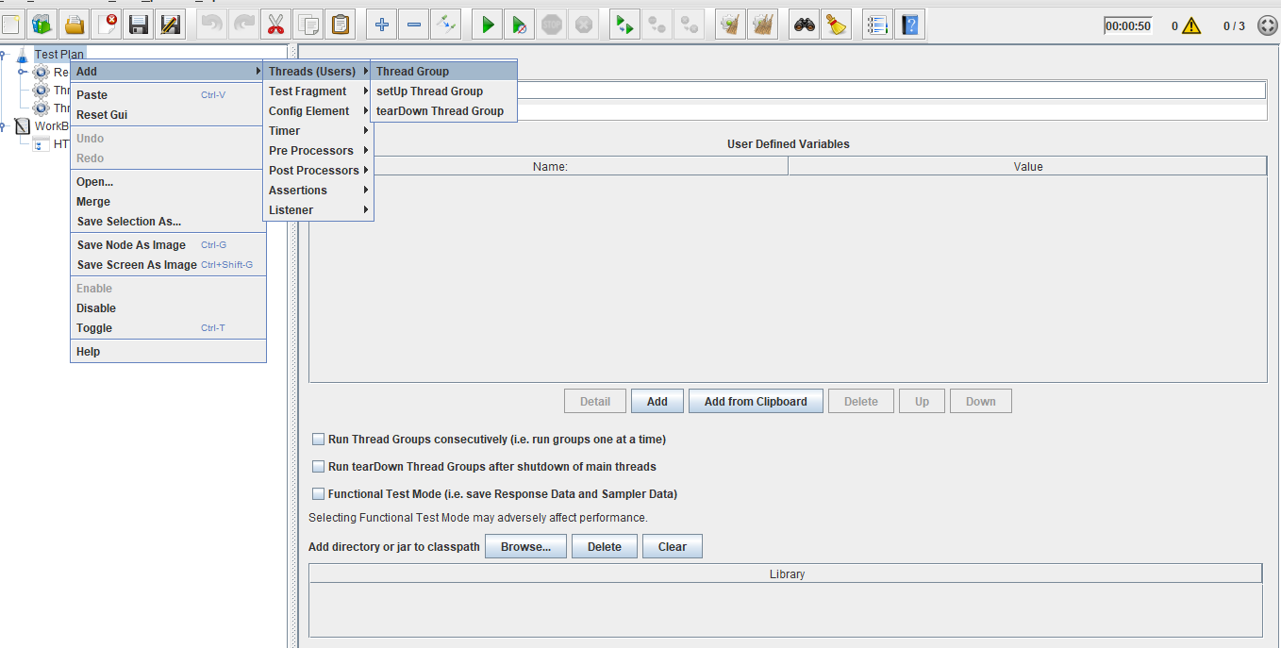

* Right click on WorkBench.
* Click on Add -> Non Test Elements ->HTTP(s) Test Script Recorder.

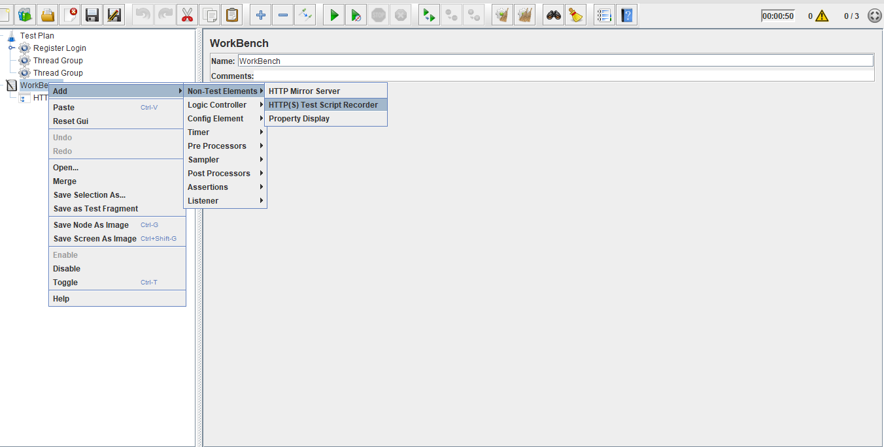

* Right click on Thread Group.
* Click on Add -> Logic Controller->Recording Controller.

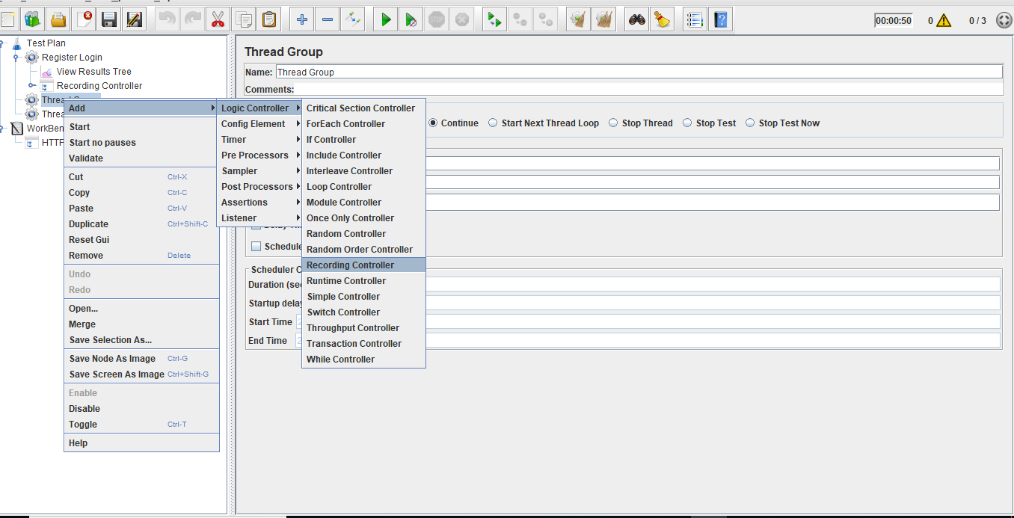

* Right click on Thread Group.
* Click on Add -> Listener->View Result in Tree.

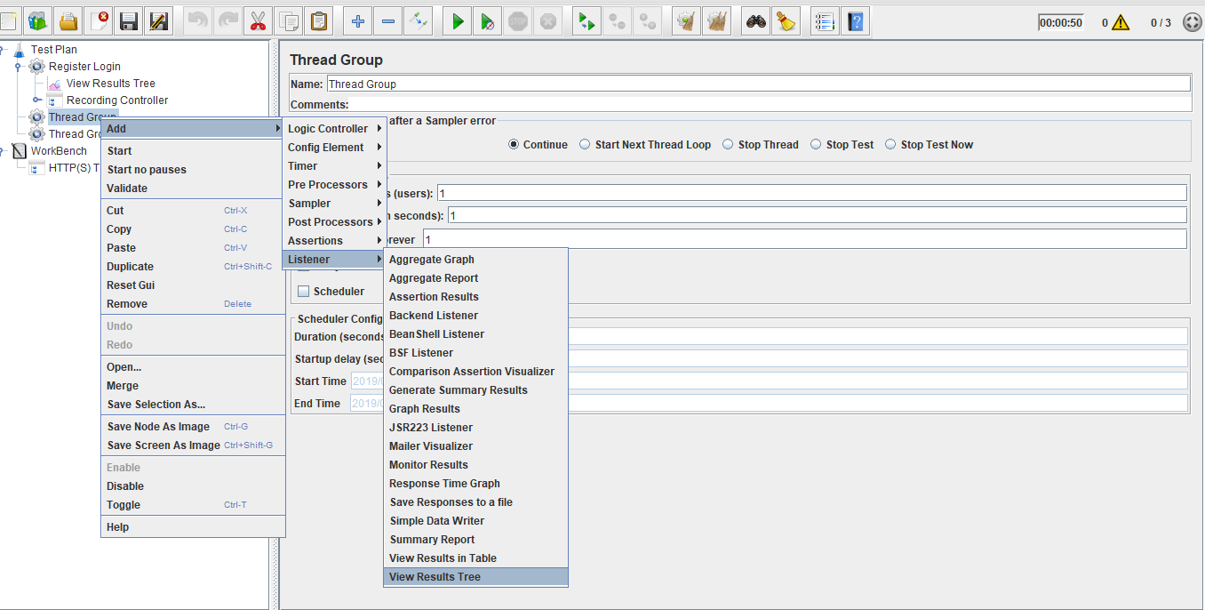

* Configure proxy settings in the browser.
* Run the scripts.
* JMeter automatically records the scripts.

**Step 1.13.2:** Adding interleave controller

* Right click on Thread Group.
* Click on Add -> Logic Controller -> Interleave Controller.

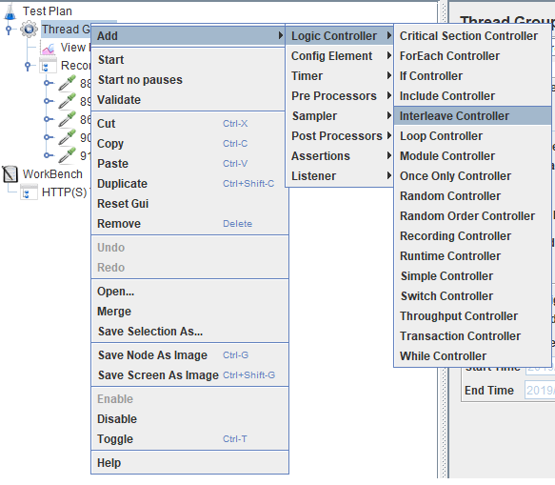

**Steps 1.13.3:** Run the scripts in interleave controller

* Recorded scripts should be added as child scripts for the interleave controller.

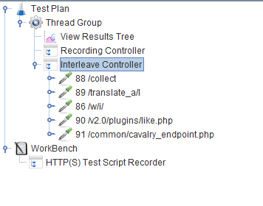

* Thread group has an option called loop count in which you can give the loop count value.
* Based on the loop count value, the output is available at that time of execution. The output will be available based on the inserted order of the interleaving controller.
* If you don’t change the loop value and try to run it frequently, you will get the equivalent output as per the result of the first execution.

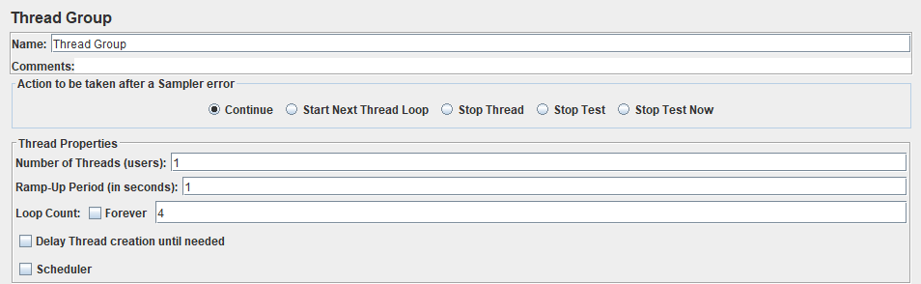

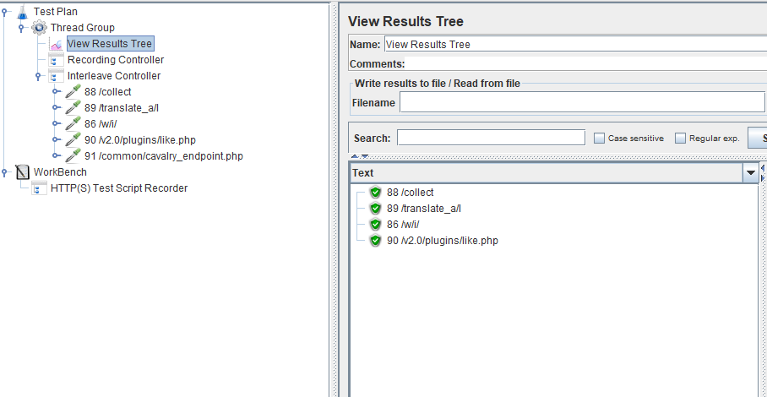

**Step 1.13.4:** Pushing the code to GitHub repositories

Open your command prompt and navigate to the folder where you have created your files.

cd <folder path>

Initialize your repository using the following command:

git init

Add all the files to your git repository using the following command:

git add . 

Commit the changes using the following command:

git commit . -m “Changes have been committed.”

Push the files to the folder you initially created using the following command:

git push -u origin master